**Creation of VPC**

Region: Mumbai

CIDR = 10.0.0.0/16 (65,536 IP Address)

Cration of Subnets for Demo-VPC

VPC – Demo-VPC

CIDR – 10.0.0.0/24 -> Public subnet (256 IP Address)

10.0.1.0/24 -> Private subnet (256 IP Address)

Creation of Internet Gateway

State: Detached

Attaching to Demo-VPC

Creation of additional Route table for public subnet

Private subnet should be associated with private route table(under subnet associations)

By default, routes destination is 10.0.0.0/16 i.e., entire VPC which we can’t remove/delete as it should be accessible .

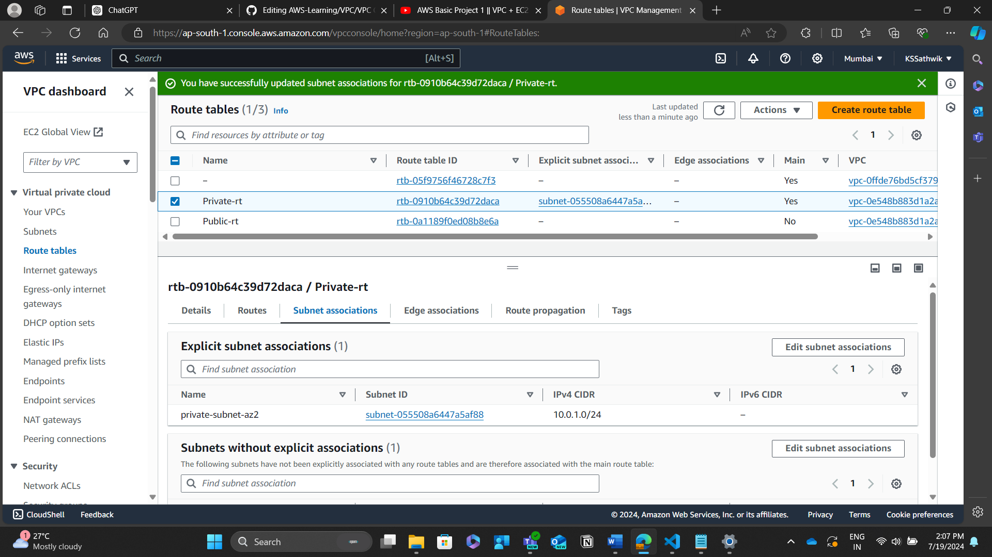

For Public route table, I am adding Internet gateway (in routes)

Associating Public subnet to it.

Create Public Instance and Private Instance

Public Instance

Name = Public-EC2

Attached to Demo-VPC, Public-subnet, created a security group of

> SSH, port 22, anywhere

>Custom, port 80, anywhere

Public IP address = No

Enabled Public DNS in Demo-VPC

Private Instance

Name = Private-EC2

Attached to Demo-VPC, Private-subnet, created a security group of

> SSH, port 22, anywhere

Public IP address = Yes

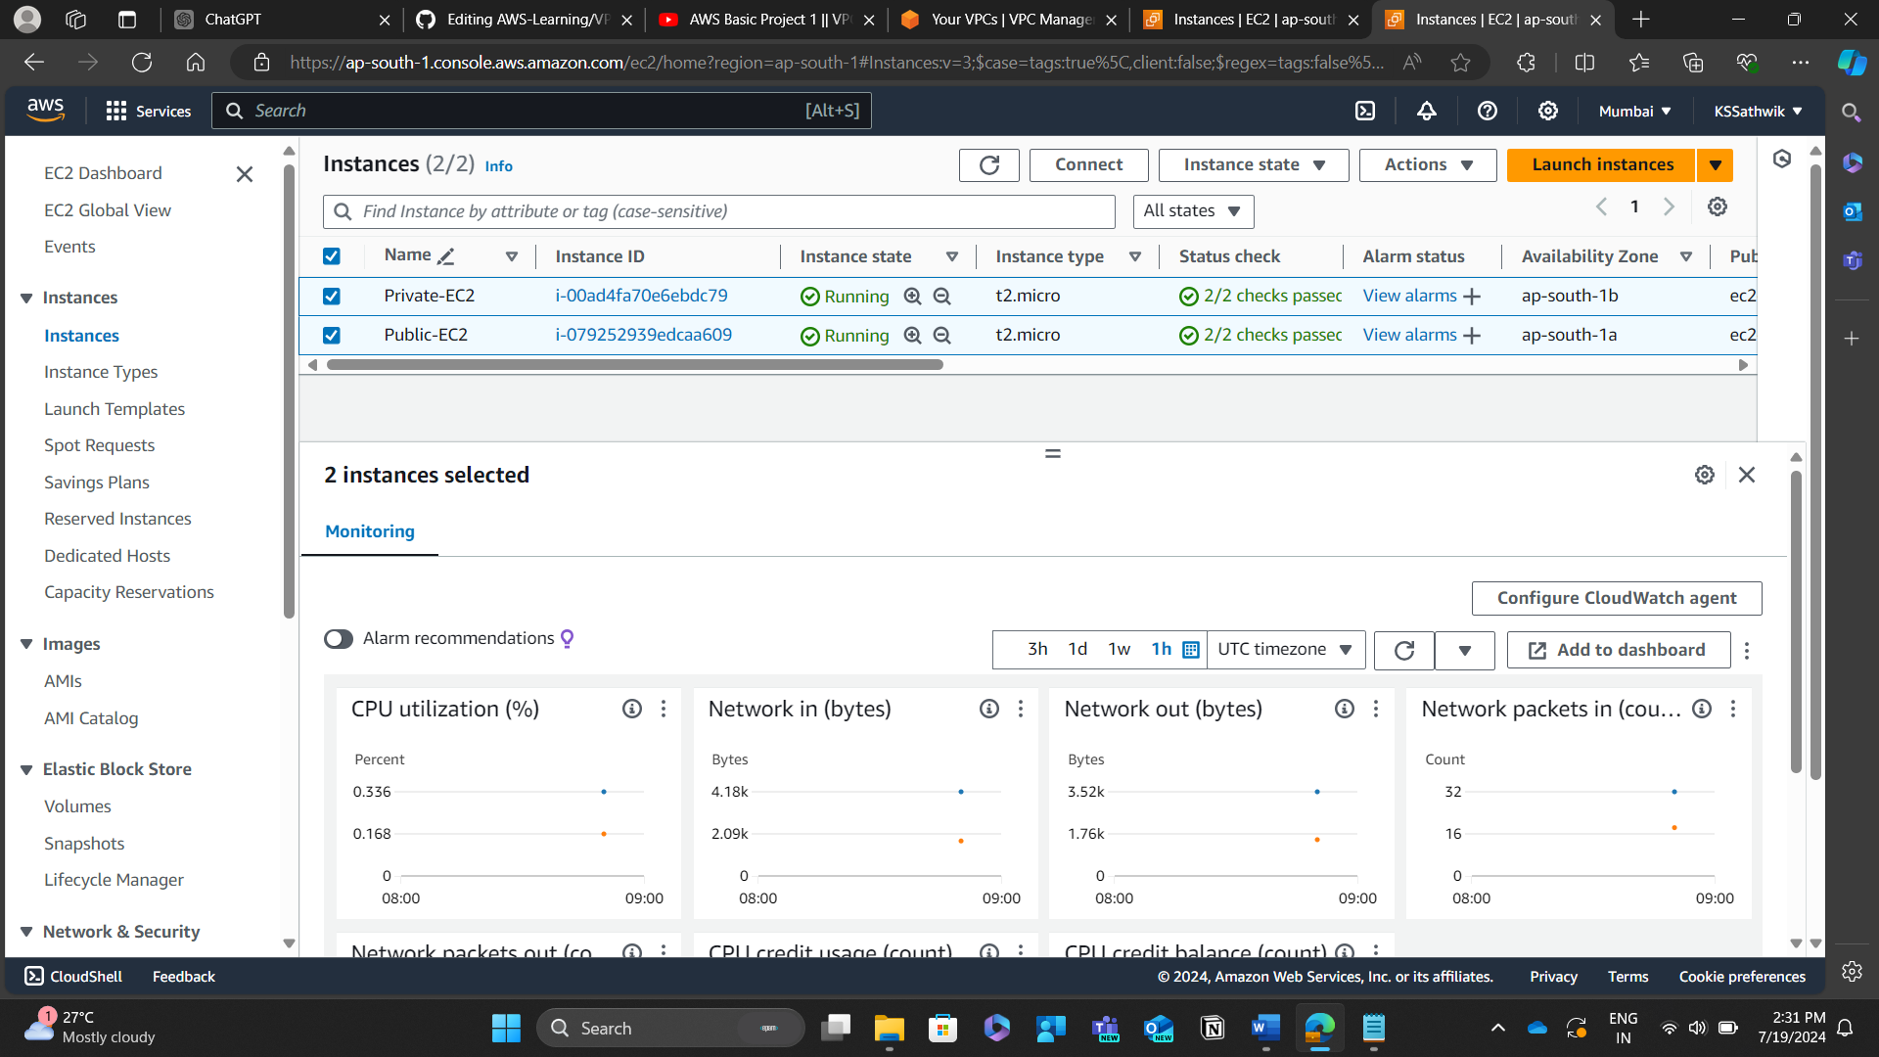

Resource MAP

